Similarity Transformation

Definition
# Source: AI Source: Provided by: [Data Path: Persons Table -> ID Column: 1, Name_En Column: Motasem Essam] -> From: [ChatGPT] on [7/25/2026]
A Similarity Transformation is a geometric transformation that maps a figure to another figure with the same shape, while its size may change.
It preserves:
- angle measures,
- shape,
- ratios of corresponding lengths,
but it does not necessarily preserve the actual lengths, perimeter, or area.
The transformation uses a constant scale factor $k$:
$$\boxed{\text{Similarity Transformation}=\text{Shape Preservation}+\text{Uniform Scaling}}$$
If $k=1$, the transformation becomes a congruence transformation.

Fundamental Concept
# Source: AI Source: Provided by: [Data Path: Persons Table -> ID Column: 1, Name_En Column: Motasem Essam] -> From: [ChatGPT] on [7/25/2026]
Suppose a figure $S$is transformed into $S^{'}$.
Every corresponding length is multiplied by the same scale factor $k$:
$$\boxed{P^{'}Q^{'}=k\left(PQ\right)}$$
for corresponding points $P,Q$.
The angles remain unchanged:
$$\boxed{m∠A^{'}=m∠A}$$
Therefore:
$$\boxed{\text{Same Shape}+\text{Possibly Different Size}}$$

Basic Structure
# Source: AI Source: Provided by: [Data Path: Persons Table -> ID Column: 1, Name_En Column: Motasem Essam] -> From: [ChatGPT] on [7/25/2026]
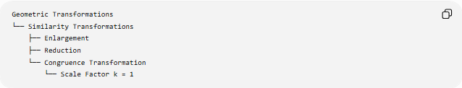
Geometric Transformations
└── Similarity Transformations
├── Enlargement
├── Reduction
└── Congruence Transformation
└── Scale Factor k = 1
A more complete transformation structure is:
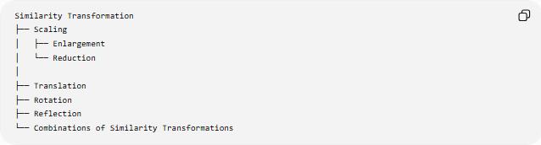
Similarity Transformation
├── Scaling
│ ├── Enlargement
│ └── Reduction
│
├── Translation
├── Rotation
├── Reflection
└── Combinations of Similarity Transformations
A similarity transformation can combine a uniform scaling with rigid motions such as translation, rotation, and reflection.

Main Characteristics
# Source: AI Source: Provided by: [Data Path: Persons Table -> ID Column: 1, Name_En Column: Motasem Essam] -> From: [ChatGPT] on [7/25/2026]
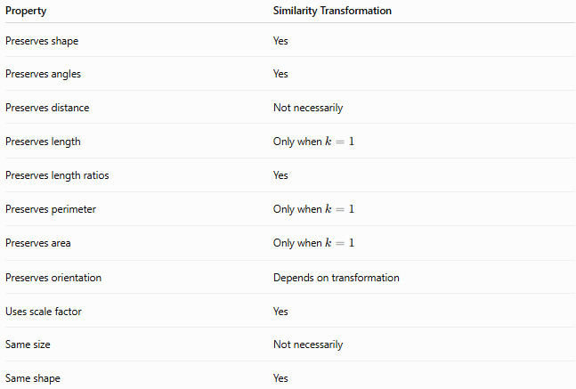
Property | Similarity Transformation
Preserves shape | Yes
Preserves angles | Yes
Preserves distance | Not necessarily
Preserves length | Only when $k=1$
Preserves length ratios | Yes
Preserves perimeter | Only when $k=1$
Preserves area | Only when $k=1$
Preserves orientation | Depends on transformation
Uses scale factor | Yes
Same size | Not necessarily
Same shape | Yes

Scale Factor
# Source: AI Source: Provided by: [Data Path: Persons Table -> ID Column: 1, Name_En Column: Motasem Essam] -> From: [ChatGPT] on [7/25/2026]
The scale factor $k$determines how the size changes.
For corresponding lengths:
$$\boxed{k=\frac{\text{Image Length}}{\text{Original Length}}}$$
or:
$$\boxed{k=\frac{A^{'}B^{'}}{AB}}$$

1-Enlargement
# Source: AI Source: Provided by: [Data Path: Persons Table -> ID Column: 1, Name_En Column: Motasem Essam] -> From: [ChatGPT] on [7/25/2026]
If:
$$\boxed{k>1}$$
the image is larger than the original.
Example:
$$k=2$$
means every length doubles.

2-Reduction
# Source: AI Source: Provided by: [Data Path: Persons Table -> ID Column: 1, Name_En Column: Motasem Essam] -> From: [ChatGPT] on [7/25/2026]
If:
$$\boxed{0<k<1}$$
the image is smaller.
Example:
$$k=\frac{1}{2}$$
means every length is reduced to half its original value.

3-Congruence
If:
$$\boxed{k=1}$$
the size does not change.
Therefore:
$$\boxed{\text{Similarity Transformation with }k=1=\text{Congruence Transformation}}$$

Coordinate Representation
# Source: AI Source: Provided by: [Data Path: Persons Table -> ID Column: 1, Name_En Column: Motasem Essam] -> From: [ChatGPT] on [7/25/2026]
A simple dilation centered at the origin is:
$$\boxed{\left(x , y\right)→\left(k , xky\right)}$$
where $k>0$.
For example, with:
$$k=2$$
we have:
$$\left(x , y\right)→\left(2 , x2y\right)$$
Every distance from the origin is doubled.

Dilation About an Arbitrary Center
# Source: AI Source: Provided by: [Data Path: Persons Table -> ID Column: 1, Name_En Column: Motasem Essam] -> From: [ChatGPT] on [7/25/2026]
If the center of dilation is:
$$C=\left(h , k\right)$$
and the scale factor is $s$, then:
$$\boxed{x^{'}=h+s\left(x-h\right)} \\ \boxed{y^{'}=k+s\left(y-k\right)}$$
This means every point moves along the line connecting it to the center of dilation.

Effect on Length
# Source: AI Source: Provided by: [Data Path: Persons Table -> ID Column: 1, Name_En Column: Motasem Essam] -> From: [ChatGPT] on [7/25/2026]
If an original length is $L$, the corresponding image length is:
$$\boxed{L^{'}=kL}$$
Example:
$$L=6\text{ cm}, k=3$$
Then:
$$L^{'}=3\left(6\right)=18\text{ cm}$$

Effect on Perimeter
# Source: AI Source: Provided by: [Data Path: Persons Table -> ID Column: 1, Name_En Column: Motasem Essam] -> From: [ChatGPT] on [7/25/2026]
Because every length is multiplied by $k$:
$$\boxed{P^{'}=kP}$$
Example:
$$P=20\text{ cm}, k=2$$
Then:
$$P^{'}=40\text{ cm}$$

Effect on Area
# Source: AI Source: Provided by: [Data Path: Persons Table -> ID Column: 1, Name_En Column: Motasem Essam] -> From: [ChatGPT] on [7/25/2026]
Area changes by the square of the scale factor:
$$\boxed{A^{'}=k^{2}A}$$
Example:
$$A=10{\text{ cm}}^{2}, k=3$$
Then:
$$A^{'}=3^{2}\left(10\right)=90{\text{ cm}}^{2}$$
So:
$$\boxed{\text{Length}→k} \\ \boxed{\text{Area}→k^{2}}$$

Effect on Volume
# Source: AI Source: Provided by: [Data Path: Persons Table -> ID Column: 1, Name_En Column: Motasem Essam] -> From: [ChatGPT] on [7/25/2026]
For three-dimensional figures, volume changes by the cube of the scale factor:
$$\boxed{V^{'}=k^{3}V}$$
Example:
$$V=5{\text{ cm}}^{3}, k=2$$
Then:
$$V^{'}=2^{3}\left(5\right)=40{\text{ cm}}^{3}$$
Therefore:
$$\boxed{\text{Length}→k} \\ \boxed{\text{Area}→k^{2}} \\ \boxed{\text{Volume}→k^{3}}$$

Effect on Angles
# Source: AI Source: Provided by: [Data Path: Persons Table -> ID Column: 1, Name_En Column: Motasem Essam] -> From: [ChatGPT] on [7/25/2026]
Similarity transformations preserve angle measures.
If:
$$∠A={60}^{∘}$$
then:
$$\boxed{∠A^{'}={60}^{∘}}$$
Thus corresponding angles remain equal.

Corresponding Length Ratios
# Source: AI Source: Provided by: [Data Path: Persons Table -> ID Column: 1, Name_En Column: Motasem Essam] -> From: [ChatGPT] on [7/25/2026]
If two figures are similar, all corresponding lengths have the same ratio:
$$\boxed{\frac{A^{'}B^{'}}{AB}=\frac{B^{'}C^{'}}{BC}=\frac{C^{'}A^{'}}{CA}=k}$$
This constant ratio is the scale factor.

Example — Triangle
# Source: AI Source: Provided by: [Data Path: Persons Table -> ID Column: 1, Name_En Column: Motasem Essam] -> From: [ChatGPT] on [7/25/2026]
Consider:
$$△ABC$$
with side lengths:
$$AB=3, BC=4, CA=5$$
Apply a similarity transformation with:
$$k=2$$
The new side lengths are:
$$A^{'}B^{'}=6 \\ B^{'}C^{'}=8 \\ C^{'}A^{'}=10$$
The triangle has changed size but not shape.
Therefore:
$$\boxed{△ABC∼△A^{'}B^{'}C^{'}}$$

Similarity Transformation vs Congruence Transformation
# Source: AI Source: Provided by: [Data Path: Persons Table -> ID Column: 1, Name_En Column: Motasem Essam] -> From: [ChatGPT] on [7/25/2026]
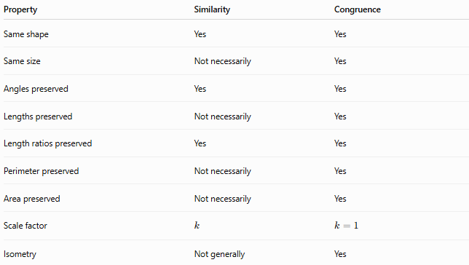
Property | Similarity | Congruence
Same shape | Yes | Yes
Same size | Not necessarily | Yes
Angles preserved | Yes | Yes
Lengths preserved | Not necessarily | Yes
Length ratios preserved | Yes | Yes
Perimeter preserved | Not necessarily | Yes
Area preserved | Not necessarily | Yes
Scale factor | $$k$$ | $$k=1$$
Isometry | Not generally | Yes
The key distinction is:
$$\boxed{\text{Congruence preserves size}}$$
while:
$$\boxed{\text{Similarity preserves shape}}$$

Similarity Transformation vs Dilation
# Source: AI Source: Provided by: [Data Path: Persons Table -> ID Column: 1, Name_En Column: Motasem Essam] -> From: [ChatGPT] on [7/25/2026]
A dilation is a fundamental type of similarity transformation.
However, a general similarity transformation may also include rigid motions.
For example:
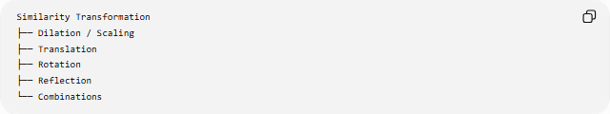
Similarity Transformation
├── Dilation / Scaling
├── Translation
├── Rotation
├── Reflection
└── Combinations
A dilation changes size around a center, while a general similarity transformation can additionally change the figure's position or orientation.

Similarity Transformation vs Scaling
# Source: AI Source: Provided by: [Data Path: Persons Table -> ID Column: 1, Name_En Column: Motasem Essam] -> From: [ChatGPT] on [7/25/2026]
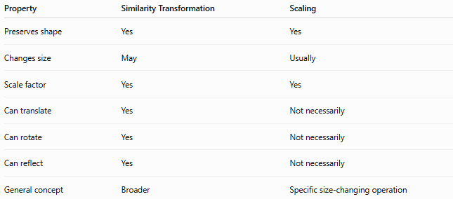
Property | Similarity Transformation | Scaling
Preserves shape | Yes | Yes
Changes size | May | Usually
Scale factor | Yes | Yes
Can translate | Yes | Not necessarily
Can rotate | Yes | Not necessarily
Can reflect | Yes | Not necessarily
General concept | Broader | Specific size-changing operation
Thus, scaling is a major component of similarity transformations.

Orientation
# Source: AI Source: Provided by: [Data Path: Persons Table -> ID Column: 1, Name_En Column: Motasem Essam] -> From: [ChatGPT] on [7/25/2026]
A similarity transformation can either preserve or reverse orientation.
Orientation-preserving
Examples:
- dilation,
- translation,
- rotation.
Orientation-reversing
Examples:
- reflection combined with scaling,
- other similarity transformations containing a reflection.
Therefore, unlike scaling alone, similarity transformations can include orientation changes.

Composition of Similarity Transformations
# Source: AI Source: Provided by: [Data Path: Persons Table -> ID Column: 1, Name_En Column: Motasem Essam] -> From: [ChatGPT] on [7/25/2026]
Similarity transformations can be combined.
For example:
$$\text{Dilation}→\text{Rotation}→\text{Translation}$$
The resulting transformation is still a similarity transformation.
In general:
$$\boxed{T_{2}∘T_{1}}$$
is a similarity transformation if $T_{1}$and $T_{2}$are similarity transformations.

Mathematical Definition
# Source: AI Source: Provided by: [Data Path: Persons Table -> ID Column: 1, Name_En Column: Motasem Essam] -> From: [ChatGPT] on [7/25/2026]
A transformation $T$is a similarity transformation if there exists a constant $k>0$such that for all points $P,Q$:
$$\boxed{d\left(T , \left(P\right)T\left(Q\right)\right)=k d\left(P , Q\right)}$$
This is the fundamental mathematical condition.
When:
$$k=1$$
we obtain:
$$d\left(T , \left(P\right)T\left(Q\right)\right)=d\left(P , Q\right)$$
which is an isometry/congruence transformation.

Similarity of Figures
# Source: AI Source: Provided by: [Data Path: Persons Table -> ID Column: 1, Name_En Column: Motasem Essam] -> From: [ChatGPT] on [7/25/2026]
Two figures are similar when one can be obtained from the other through a similarity transformation.
The notation is:
$$\boxed{A∼B}$$
For similar triangles:
$$\boxed{△ABC∼△A^{'}B^{'}C^{'}}$$
Corresponding angles are equal:
$$∠A=∠A^{'} \\ ∠B=∠B^{'} \\ ∠C=∠C^{'}$$
and corresponding sides are proportional:
$$\boxed{\frac{A^{'}B^{'}}{AB}=\frac{B^{'}C^{'}}{BC}=\frac{C^{'}A^{'}}{CA}}$$

Important Properties
# Source: AI Source: Provided by: [Data Path: Persons Table -> ID Column: 1, Name_En Column: Motasem Essam] -> From: [ChatGPT] on [7/25/2026]
Length
$$\boxed{L^{'}=kL}$$
Perimeter
$$\boxed{P^{'}=kP}$$
Area
$$\boxed{A^{'}=k^{2}A}$$
Volume
$$\boxed{V^{'}=k^{3}V}$$
Angles
$$\boxed{θ^{'}=θ}$$
Distance ratio
$$\boxed{\frac{d\left(T , \left(P\right)T\left(Q\right)\right)}{d\left(P , Q\right)}=k}$$

Classification
# Source: AI Source: Provided by: [Data Path: Persons Table -> ID Column: 1, Name_En Column: Motasem Essam] -> From: [ChatGPT] on [7/25/2026]
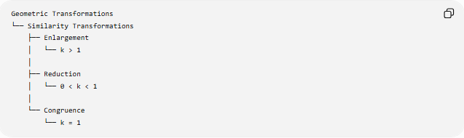
Geometric Transformations
└── Similarity Transformations
├── Enlargement
│ └── k > 1
│
├── Reduction
│ └── 0 < k < 1
│
└── Congruence
└── k = 1
A more transformation-oriented classification is:
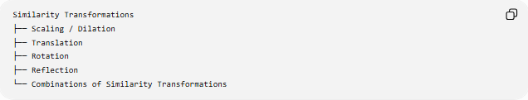
Similarity Transformations
├── Scaling / Dilation
├── Translation
├── Rotation
├── Reflection
└── Combinations of Similarity Transformations

Relationship with Congruence
# Source: AI Source: Provided by: [Data Path: Persons Table -> ID Column: 1, Name_En Column: Motasem Essam] -> From: [ChatGPT] on [7/25/2026]
The relationship can be summarized as:
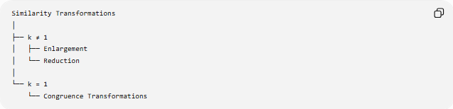
Similarity Transformations
│
├── k ≠ 1
│ ├── Enlargement
│ └── Reduction
│
└── k = 1
└── Congruence Transformations
Therefore:
$$\boxed{\text{Every congruence transformation is a similarity transformation}}$$
but:
$$\boxed{\text{Not every similarity transformation is a congruence transformation}}$$

Key Points
# Source: AI Source: Provided by: [Data Path: Persons Table -> ID Column: 1, Name_En Column: Motasem Essam] -> From: [ChatGPT] on [7/25/2026]
- A Similarity Transformation preserves shape.
- It preserves all corresponding angle measures.
- Corresponding lengths are multiplied by the same scale factor $k$.
- $k>1$produces an enlargement.
- $0<k<1$produces a reduction.
- $k=1$produces a congruence transformation.
- Lengths scale by $k$.
- Perimeters scale by $k$.
- Areas scale by $k^{2}$.
- Volumes scale by $k^{3}$.
- The fundamental mathematical condition is:
$$\boxed{d\left(T , \left(P\right)T\left(Q\right)\right)=k d\left(P , Q\right)}$$

Conclusion
# Source: AI Source: Provided by: [Data Path: Persons Table -> ID Column: 1, Name_En Column: Motasem Essam] -> From: [ChatGPT] on [7/25/2026]
A Similarity Transformation is a transformation that preserves the shape of a figure while allowing its size to change by a constant scale factor $k$. It preserves angles and ratios of corresponding lengths:
$$\boxed{d\left(T , \left(P\right)T\left(Q\right)\right)=k d\left(P , Q\right)}$$
The scale factor determines the size change:
$$\boxed{k>1→\text{Enlargement}} \\ \boxed{0<k<1→\text{Reduction}} \\ \boxed{k=1→\text{Congruence}}$$
Thus, congruence is a special case of similarity in which the scale factor is exactly $1$.

